**PROJECT - 2**

**1.Introduction**

* Deploy a static website on aws

**2.Implementation Steps**

* Create s3 bucket
* Upload html files
* Enable static website hosting on s3

**3.Testing website**

* copy its object url , and search it in new tab.
* **INTRODUCTION**

**Deploy a Static Website on AWS**

* In this project, we will learn how to create a static website and deploy it using AWS services.

* A static website is a site that consists of HTML, CSS, and JavaScript files, and it doesn't require server-side processing or a database.
* **IMPLEMENTATION STEPS**

**Sign in to AWS Management Console**

1. Click on the Open Console button, and you will get redirected to AWS Console in a new browser tab.
2. On the AWS sign-in page,
   * Leave the Account ID as default. Never edit/remove the 12-digit Account ID present in the AWS Console. otherwise, you cannot proceed with the lab.
   * Now copy your User Name and Password in the Lab Console to the IAM Username and Password in AWS Console and click on the Sign in button.

1. Once Signed in to the AWS Management Console, Make the default AWS Region

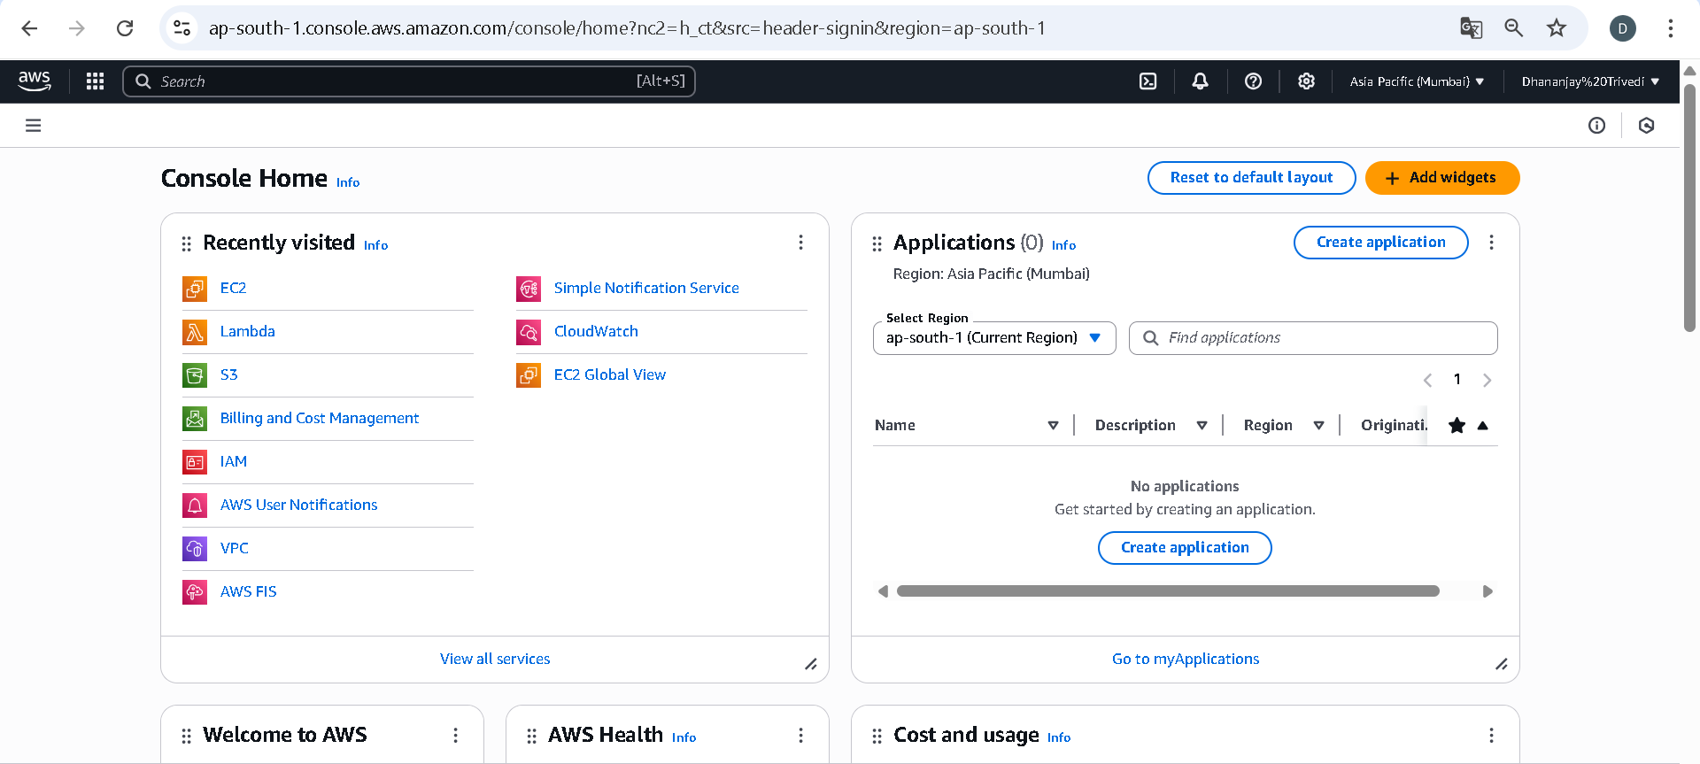

**S3 BUCKET:**

Amazon S3 (Simple Storage Service) is a cloud-based storage service provided by AWS, it allows users to store and retrieve data over the Internet. It provides a scalable, reliable, and highly available storage infrastructure for a variety of data types, including object storage, files, documents, and multimedia content.

**1. Creating an S3 Bucket for Static Website Hosting**

On your AWS console, search for S3, and on the S3 dashboard "Create bucket".

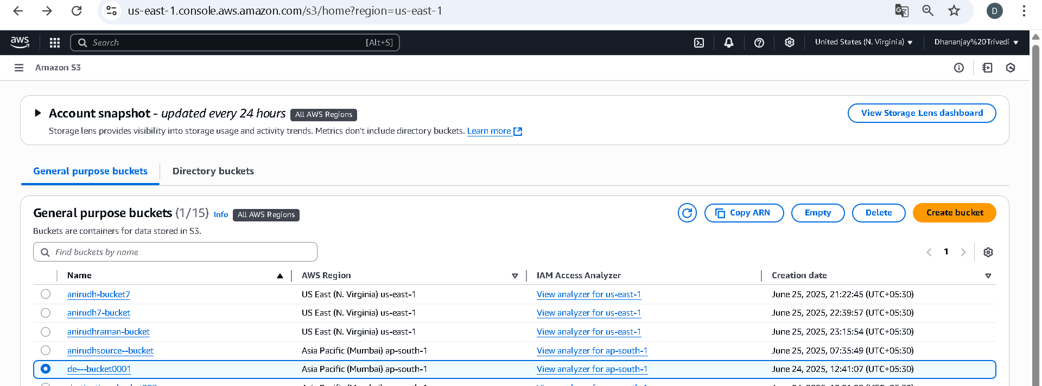

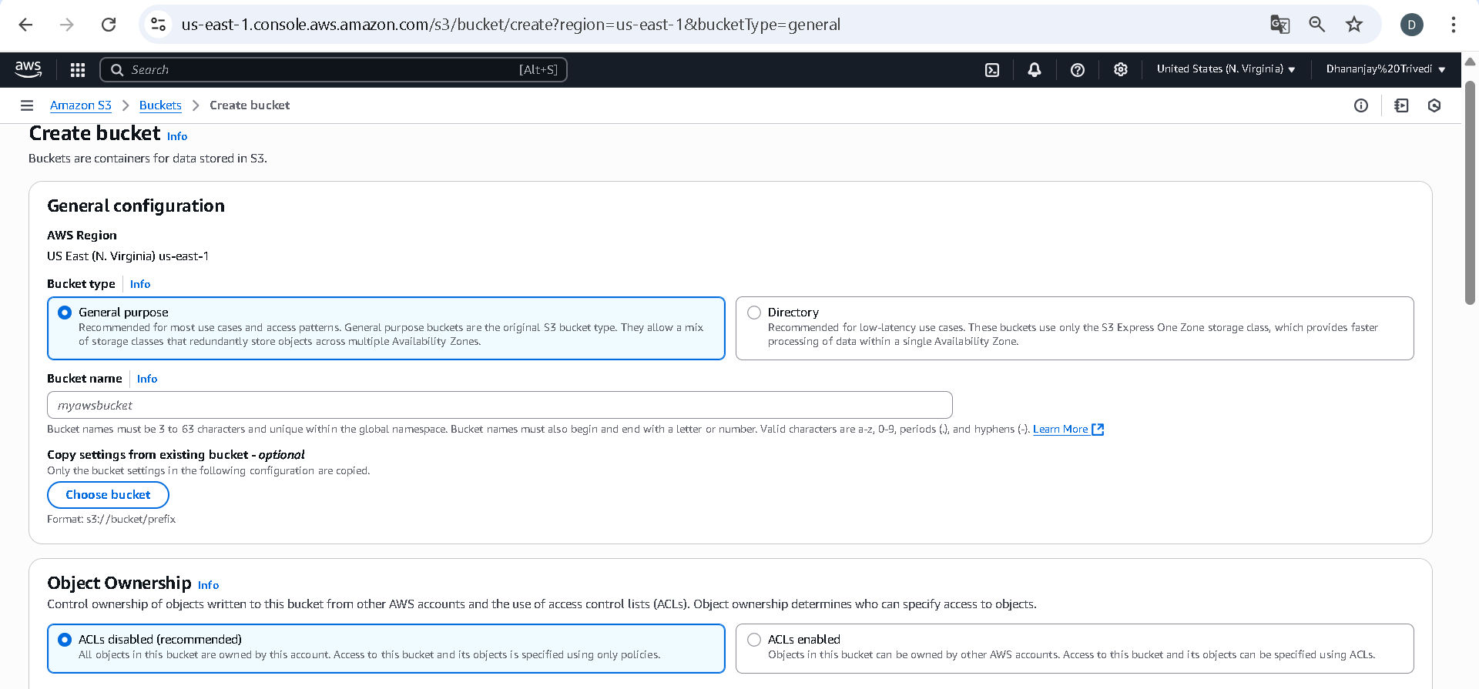

1.Select ACLs enabled option

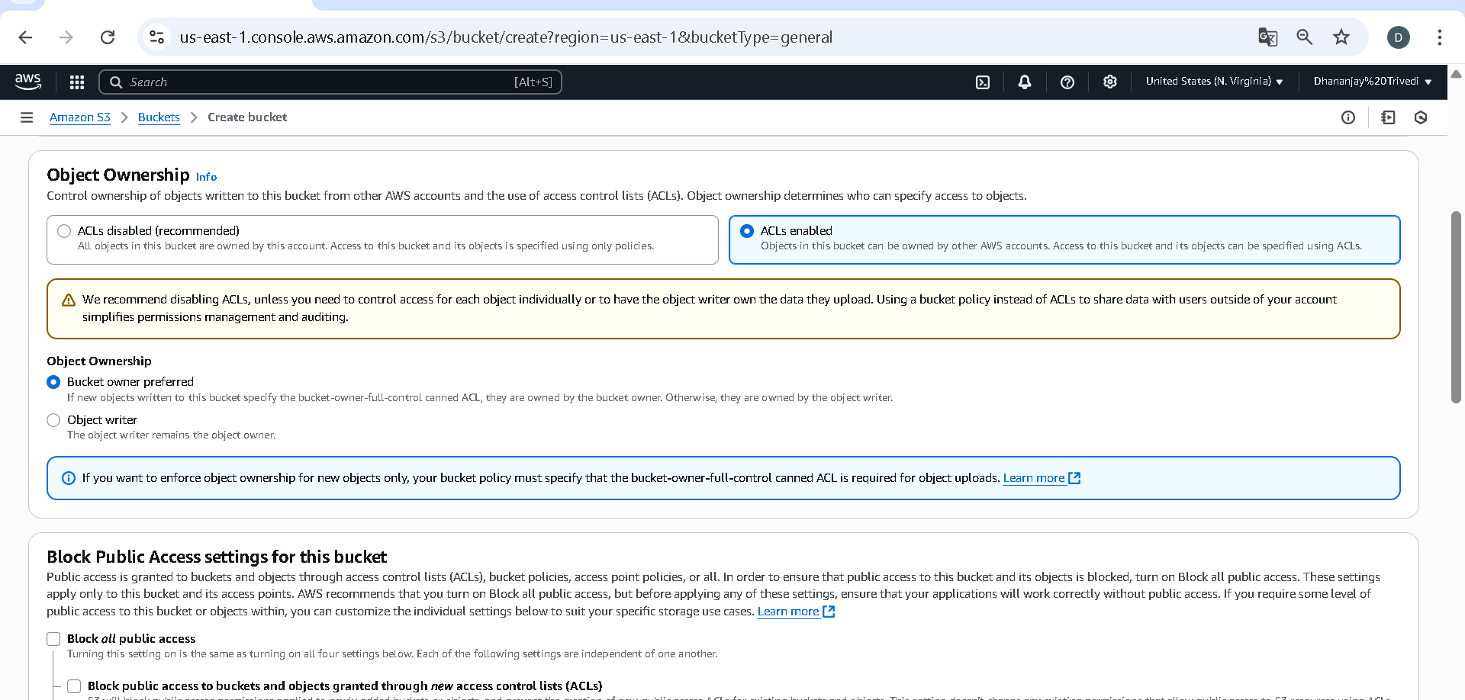

**then uncheck the "block all public access" and check the acknowledgment, then leave the rest of the configuration as default.**

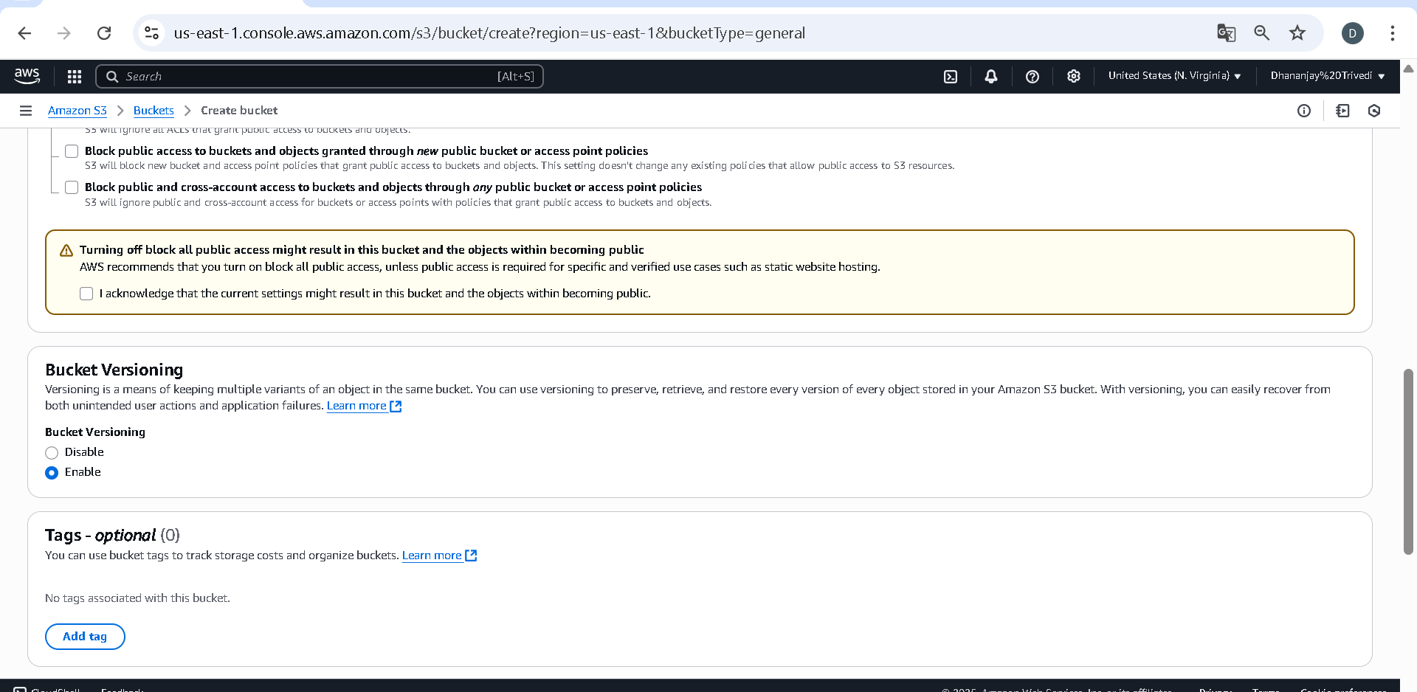

**NOTE:** Keep everything default and click on Create Bucket button.

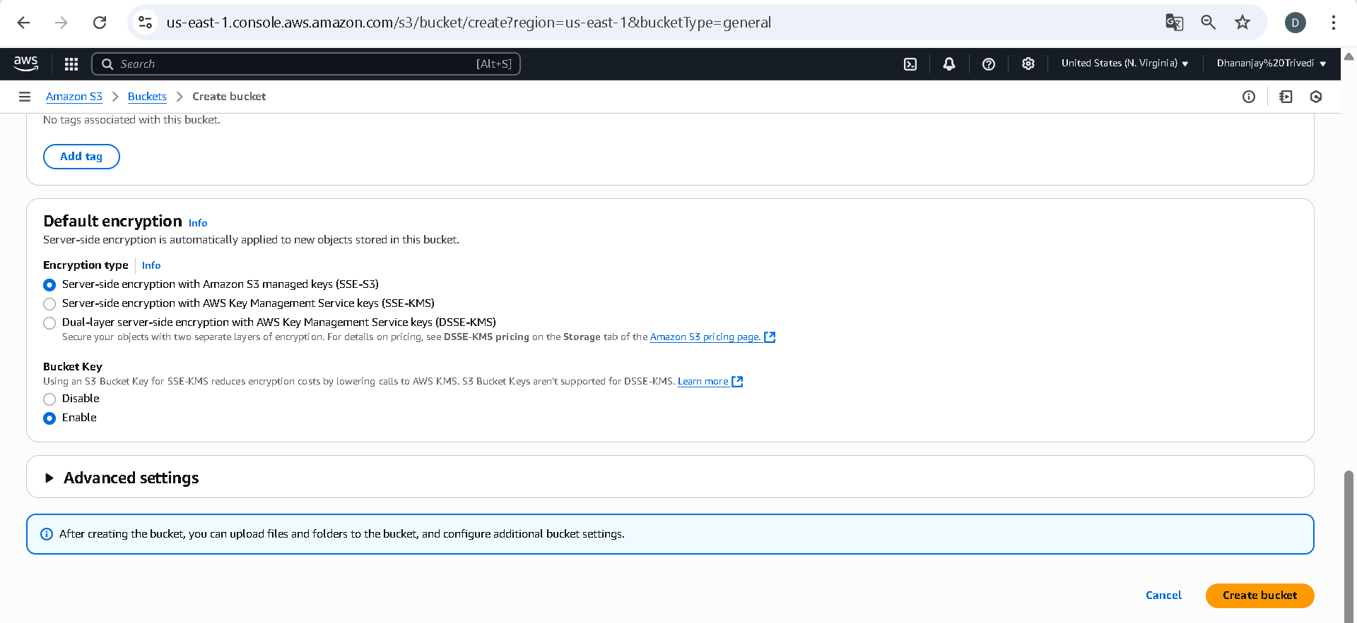

# Uploading Website Content to S3

Click on your S3 bucket, click on Upload, then click on **" Add files"**, Select and upload your website files (HTML files).

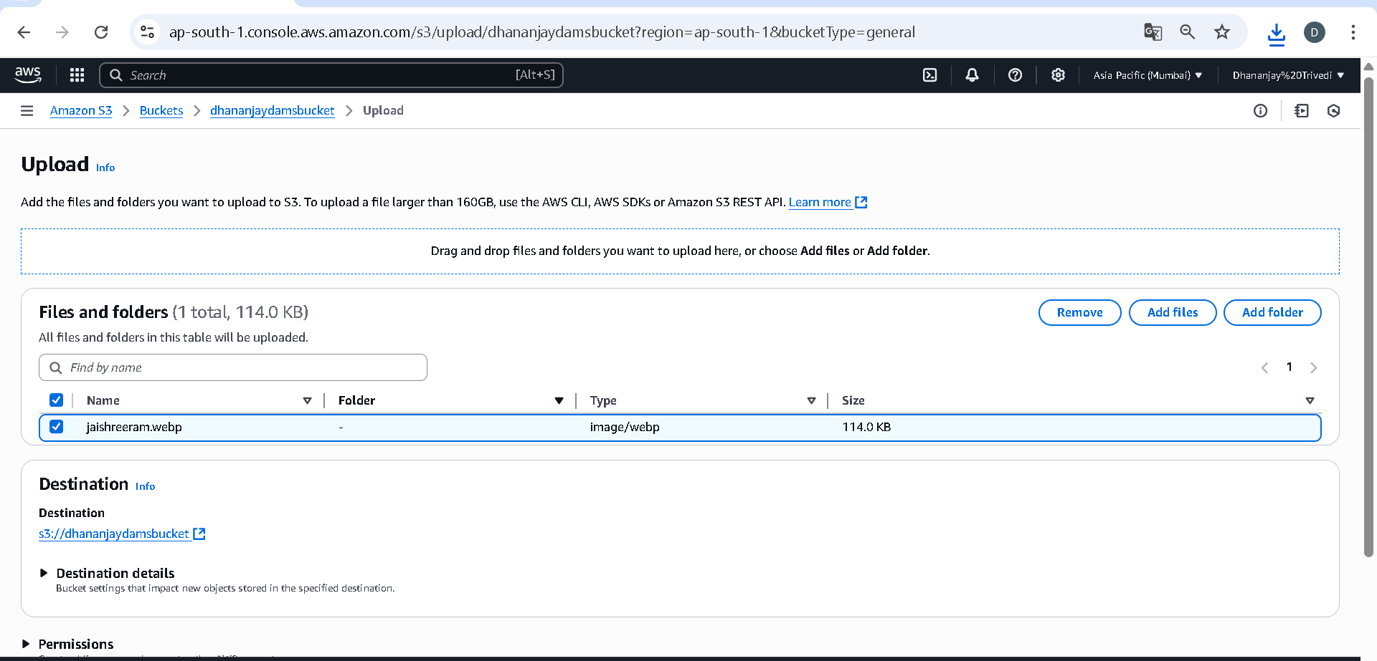

# Configuring S3 Bucket Permissions for Website Access

Click on the permission tab in your S3 bucket, click on edit permission, and paste the this Json configuration:

{

"Version": "2012-10-17",

"Statement": [

{

"Sid": "AddPerm",

"Effect": "Allow",

"Principal": "*",

"Action": "s3:GetObject",

"Resource": " arn:aws:s3:::anujbucket24/*"

}

]

}

Replace the ***"*** *ANUJBUCKET24****"*** in the configuration with your bucket name and click on save

# Enabling Static Website Hosting on S3

Click on the properties tab in your S3 bucket, scroll down , and click on "static hosting", *by default it is disabled*, click on enable static hosting, follow the configration in the snapshot, and save.



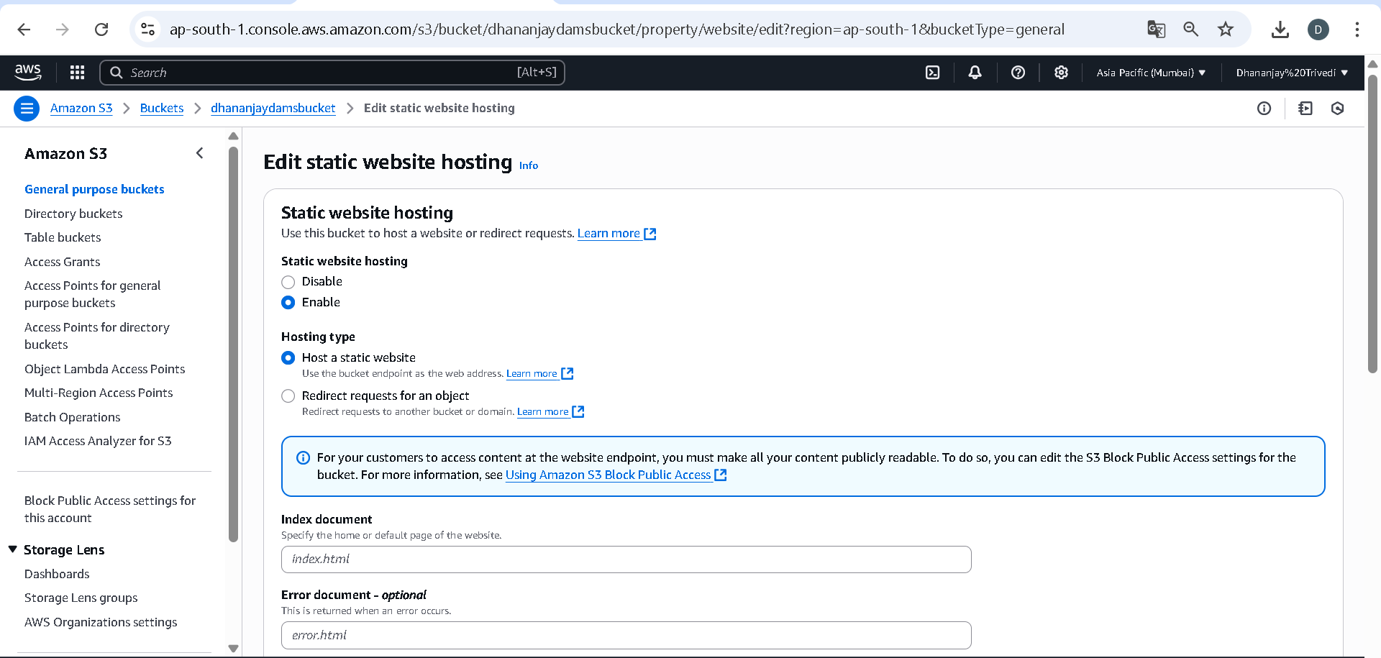

In INDEX DOCUMENT provide your html file name.

And the error document in not necessary it is optional, then scroll down and click on SAVE CHANGES .

Then inside your bucket locate your html file and open it.

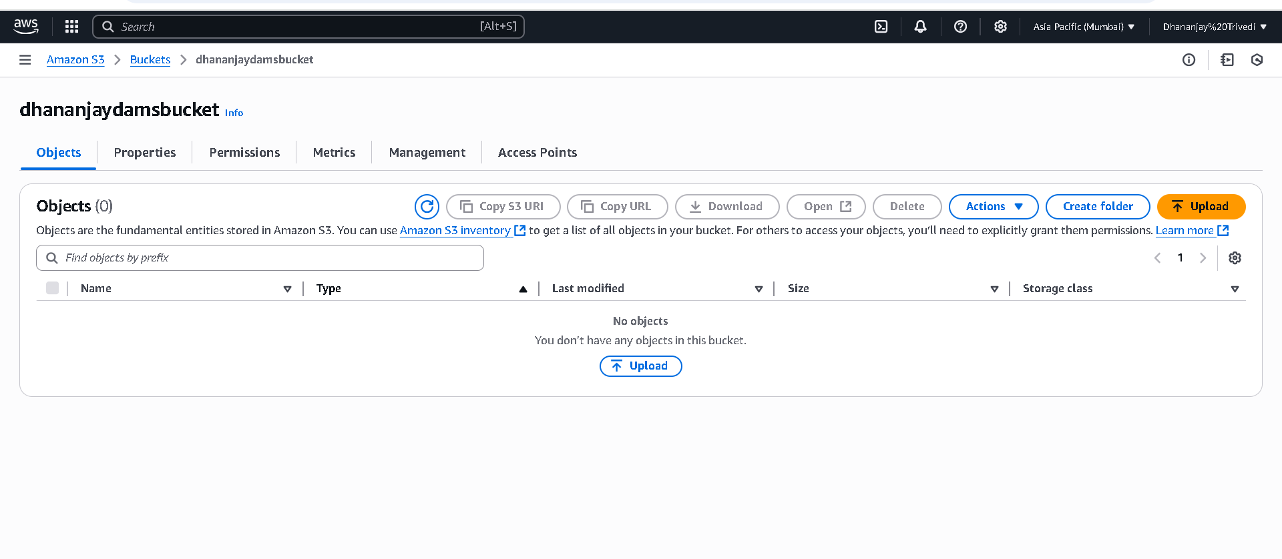

Then open your html file and copy its object url , and search it in new tab.

* **TESTING URL, WEBSITE**

